1.Project Title: HIGH QUALITY FACIAL RECOGNITION SYSTEM

2.Introduction:

Face recognition system is a technology that can detect or verify a person from a digital photo or video frame from a video source. There are many ways in which facial recognition systems work, but in general, they work by comparing selected facial features from a given image with faces within the data. It is also described as an application based on Biometric Artificial Intelligence that can identify a person differently by analysing patterns based on the person's texture and shape.

2.1Overview:

A High-Quality Facial recognition system using OpenCV and Deep Learning Algorithms (SVM classifier) to recognize the face of a person from the data fed to the system. Encoding the faces to get patterns of the person and then building a HTML file where images of a person can be uploaded and check the prediction of the system whether it recognizes the person or not.

2.2Purpose:

Face detectors are built into computer programs that analyse human face images for the purpose of self-identification. Unlike many other biometric systems, face recognition can be used for high-resolution surveillance in conjunction with public video cameras, and can be used in a way that does not require information, permission, or subject participation.

**3.Result:** 3.1 Screen Shots of the Output

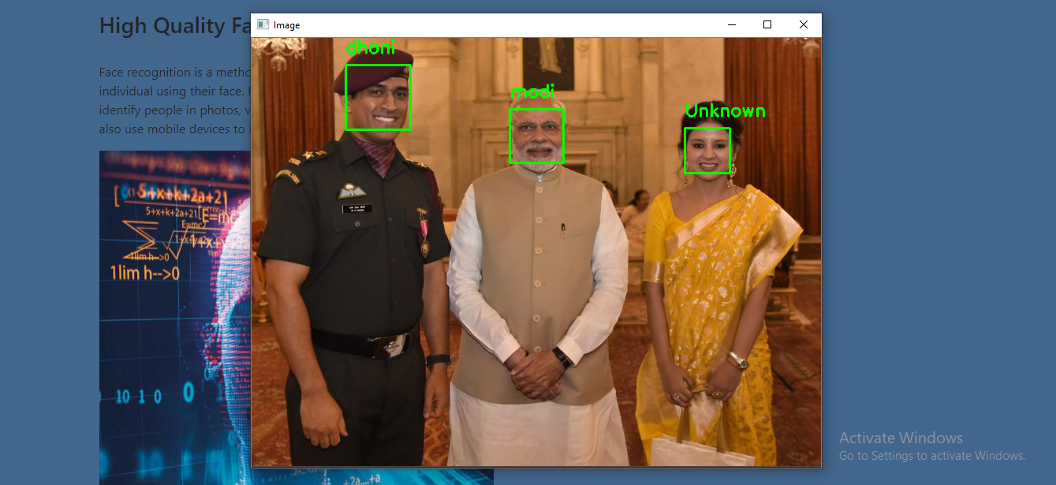

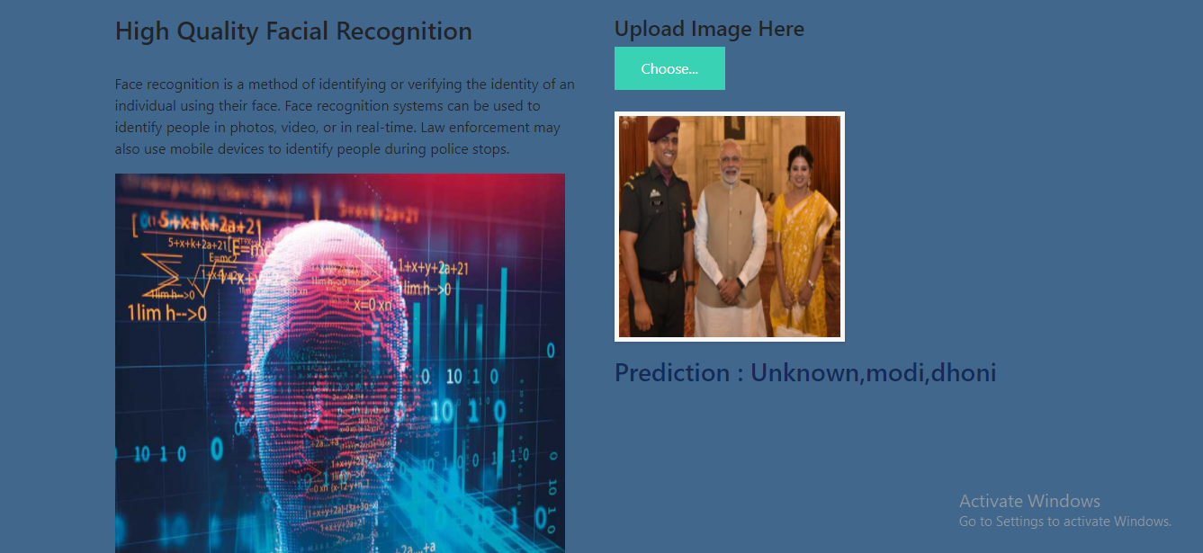

**4.Applications:**

1.Improved Surveillance - The first thing to do with it is the look of observation. With the help of face recognition, it will be easy to track down any burglars, thieves, or other criminals.

2. Fast performance - The face recognition process takes a second or less - and this is very beneficial for companies.

3. Seamless integration - This is one of the biggest benefits for companies. Face detection technology is easily integrated and therefore a complete choice.

4.Automation of Identification - In the past, security guards had to use high-speed personal visibility and not boast of high accuracy. But today, facial recognition is completely independent of the diagnostic process and can take not only seconds but also incredibly accurate.

3D facial recognition technology and the use of infrared cameras greatly increased the accuracy of facial recognition and made it really difficult to deceive.

**5.Conclusion:**

It is my idea that research on facial recognition is interesting space for many years to come and will save many scientists as well engineers are busy. By this project we have a built a program that identifies a person from the data that already have been fed to the system. With this program we can add any number of images to system and the system will be able to predict the correct person.

**6.Future Scope:**

In the future, 2D and 3D Face Recognition with a larger scale application such as e-commerce, student ID, digital driver licenses, or national IDs are a challenging task at hand recognition & title is open to further research.